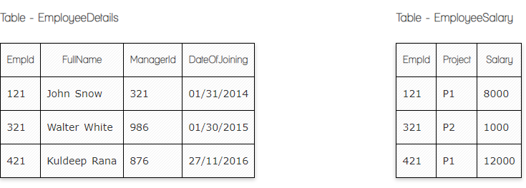

**Ques.1. Write a SQL query to fetch the count of employees working in project 'P1'.**

**Your Answer:**

Select count (EmpID), project from EmployeeSalary

group by project having project= ‘P1’;

**Ques.2. Write a SQL query to fetch employee names having salary greater than or equal to 5000 and less than or equal 10000.**

**Your Answer:**

Select EmployeeDetalis.FullName from EmployeeDetalis

inner join EmployeeSalary on EmployeeDetails.EmpID=EmpoyeeSalary.EmpID

where EmployeeSalary.Salary 5000 between 10000;

**Ques.3. Write a SQL query to fetch count of employees sorted by project's count in descending order.**

**Your Answer:**

Select count (EmpID) project, from EmployeeSalary

group by project

order by (EmpID) desc.;

**Ques.4. Write a query to fetch employee names and salary records. Return employee details even if the salary record is not present for the employee.**

**Your Answer:**

Select EmployeeDetails.FullName, EmployeeSalary.Salary from EmployeeDetails

left join EmployeeSalary on EmployeeDetails.EmpID=EmpoyeeSalary.EmpID;

**Ques.5. Write a SQL query to create an empty table with ‘Test’ name.**

**Your Answer:**

Create table ‘Test’ (

ID int NOT NULL,

Name varchar (255) NOT NULL

Category

);

**Ques.6. Write a SQL query to delete an empty table with ‘Test’ name.**

**Your Answer:**

Drop table ‘Test’;

**Ques.7. Write a SQL query to fetch all the Employees details from EmployeeDetails table who joined in Year 2016.**

**Your Answer:**

Select * from EmployeeDetails

where Year (DateofJoining) = 2016;

**Ques.8. Write a SQL query to insert new record to the EmployeeDetails table with any data.**

**Your Answer:**

Insert into EmployeeDetails ( FullName, Managerid, DateOfJoining)

Values ( ‘Gohar Galstyan’, 321, ‘02/19/2024’ );

**Ques.9. Write a SQL query to update EmployeeSalery table with setting Salary to 2000 for Project P2.**

**Your Answer:**

Update EmpoleeSalary set salary=2000 where project= ‘P2’;

**Ques.10. Write a SQL query to right join both tables and draw the results.**

**Your Answer:**

Select addresses.street, addresses.city, users.id, users.full_name from users

right join addresses on users.id= addresses.user_id;

|  |  |  |  |
| --- | --- | --- | --- |
| **Street** | **City** | **ID** | **Full_name** |
| 1.Market Street | San Francisco | 1 | John Smith |
| 2.Elm Street | San Francisco | 2 | Alice Walker |
| 3.Main Street | Boston | 3 | Harry Poter |

Select addresses.street, addresses.city, users.id, users.full_name from addresses right join users on addresses.user_id = user.id;

|  |  |  |  |
| --- | --- | --- | --- |
| **Street** | **City** | **ID** | **Full_name** |
| 1.Market Street | San Francisco | 1 | John Smith |
| 2.Elm Street | San Francisco | 2 | Alice Walker |
| 3.Main Street | Boston | 3 | Harry Poter |
| NULL | NULL | 5 | Jane Smith |

**Now take these two tables:**

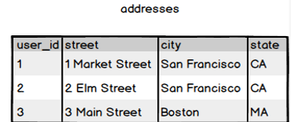

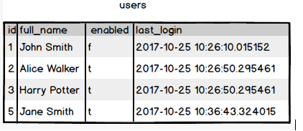

**Ques.11. Write a SQL query to fetch all users full_name from San Francisco.**

**Your Answer:**

Select users.full_name from users

inner join addresses on users.id=addresses.user_id

where addresses.city= ‘San Francisco’;

**Ques.12. Write a SQL query to fetch all users full_name, last_login who are enabled**

**Your Answer:**

Select full_name, last_login from users where enabled = ‘t’;

**Ques.13. Write a SQL query to fetch all users full_name who are not from Main street**

**Your Answer:**

Select users.full_name from users

inner join addresses on users.id=addresses.user_id

where not addresses.street= ‘Main Street’;

**Ques.14. Write a SQL query to fetch all users full_name who are from Main street or San Francisco**

**Your Answer:**

Select users.full_name from users

inner join addresses on users.id=addresses.user_id

where addresses.street= ‘Main Street’ or addresses.city= ‘San Francisco’;

**Ques.15. Write a SQL query to fetch user full_name who is equal to user_id from Boston (find user_id value in sub_query)**

**Your Answer:**

Select full_name from users

where id = (Select user_id from addresses where city= ‘Boston’ );